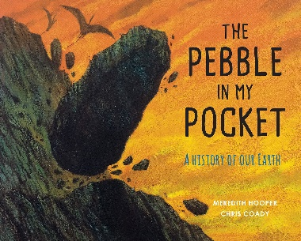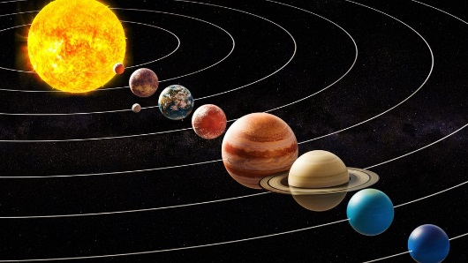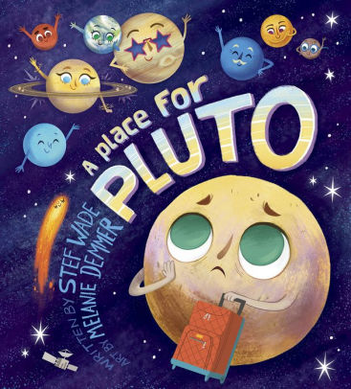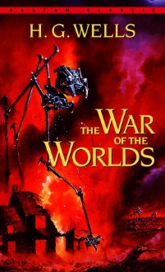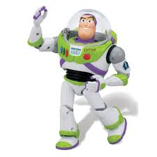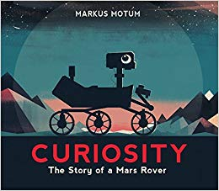

As spiritual people, we will explore:

What does it mean to be a Christian in Britain today?

Why do some people believe God exists?

Harvest & Christmas festivals.

If you have any great Space resources or knowledge we would love to hear from you.

Many thanks

The KS2 Team

Personally and socially we will be discussing our values, our uniqueness and the pressures the internet has on our friendship groups.

Reading and Writing

As well as following our English curriculum for Phonics, Grammar, Spelling and Handwriting, we will also be using a variety of texts for Guided Reading and as an inspiration for our Writing, including:

*The Pebble in my Pocket, War of the World, Level Up and many other novels* to extend and enhance our reading & comprehension skills.

We will be sharing and performing rhymes and poems on National Poetry Day on 3rd October on the theme of *What a Wonderful World!*

As healthy people, we will be thinking about the safety of ourselves and others. We will learn how to identify a problem and take responsibility for our actions.

We will have a visit from ‘Harold’ in his ‘Life Bus’ on the 9th September.

As members of our community, we will find out about many children’s authors and as part of Black History month in October we will be learning about influential people.

As linguists, we will be extending our knowledge of French by learning greetings, numbers, colours and some animals.

We will develop our *Diamond Power* by learning how to identify a problem and take responsibility for our actions.

As geographers and scientists, we would like to explore:

* What type of rocks are there in space?
* How do they make satellites and what do they do?
* How many planets are there?
* How do they drive the buggy on Mars?
* Why do the moon and other planets have craters on them?
* What are planets made of?
* Is there life on other planets?
* What is space rubbish?

As historians, we would like to explore:

* Who was the first person on the moon?
* Who is NASA?
* Who made the first space rocket?
* How long have we been exploring and travelling in space?

As artists and musicians, we would like to explore:

* The Planets music by Gustav Holst
* The colours of plants

As users of technology, we would like to explore:

* Designing a space game using coding
* Moon buggies – use electric car pack
* STEM workshop
* Creating a space rocket that flies

Maths

As well as our maths curriculum, we will also look at the distance planets are from each other, scale, relative size and weight.

Estimate the time to travel to each planet.

The cost of making a space ship and sending it on a mission to space.

**To infinity & beyond**