You’ll come up the safe path and stand at the yellow lines until it’s your turn to go in

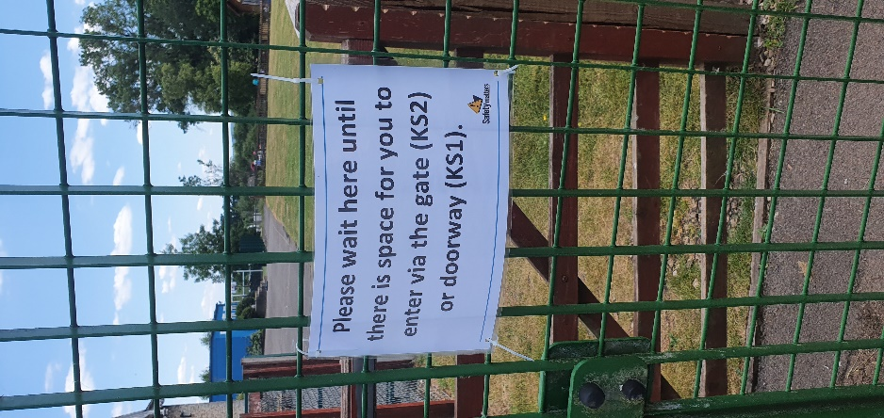

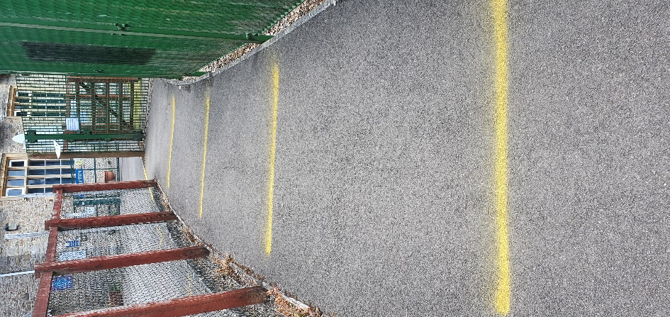

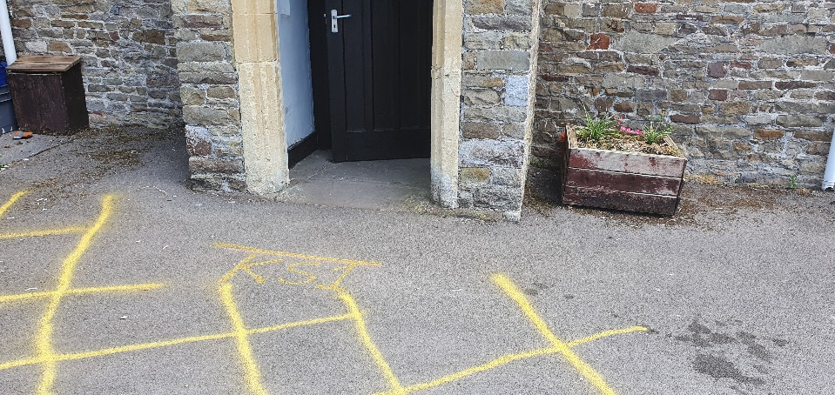

KS1 will come in the wooden door and sit in the hall. Miss Smith will meet you. You will leave your mum or dad at the door.

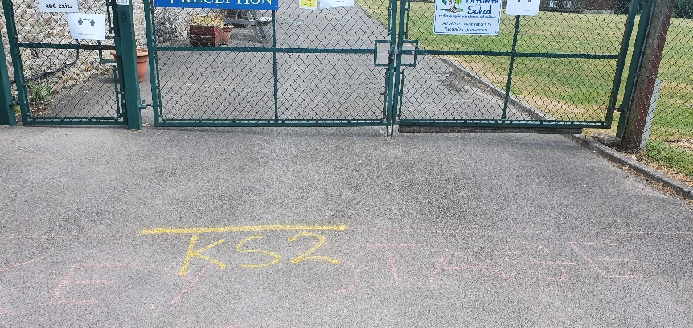

KS2 will come in the big gate. Miss Bowes will meet you. You will leave your mum or dad at the gate.

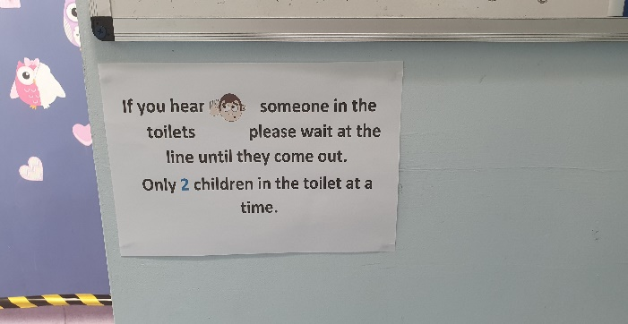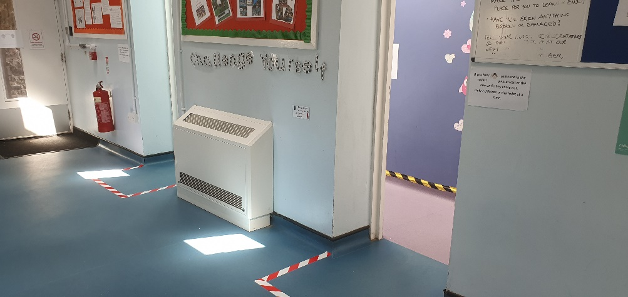

Waiting outside toilets – only 2 in at a time.

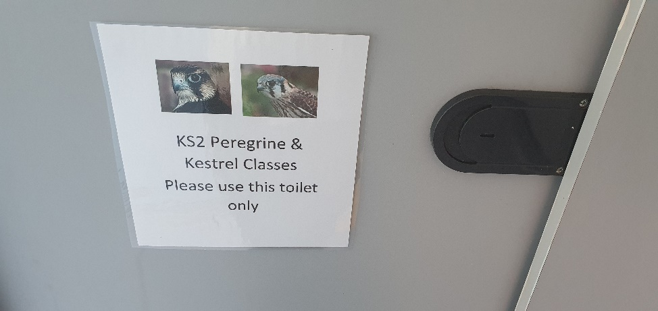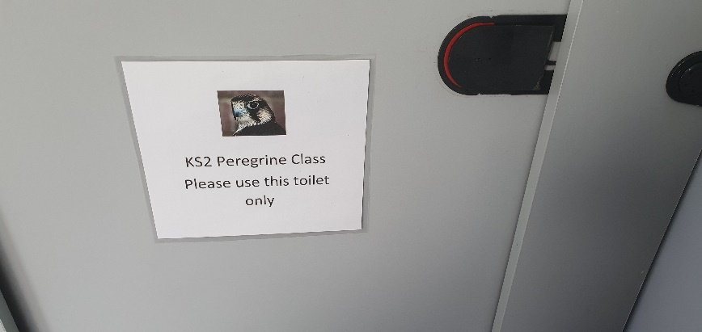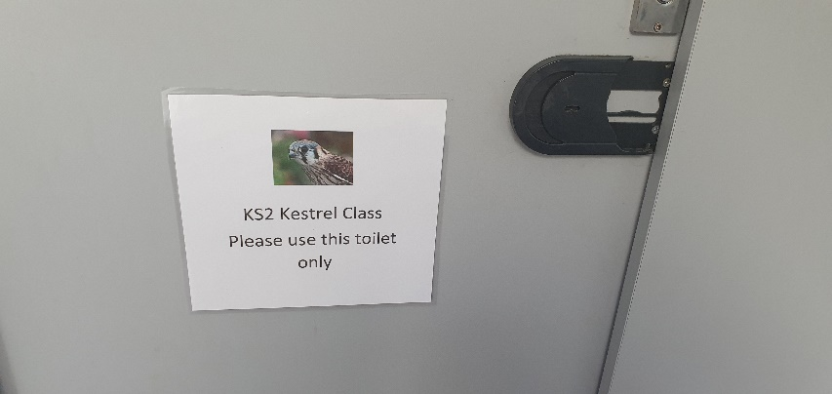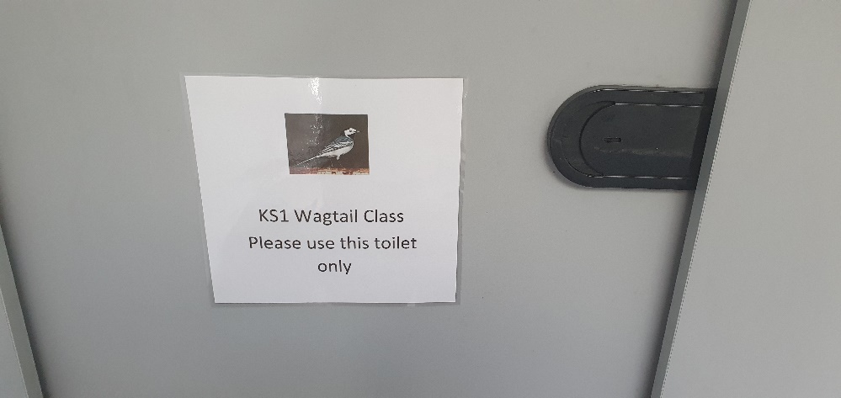

Use your class toilet only

Boys, please don’t use the urinal.

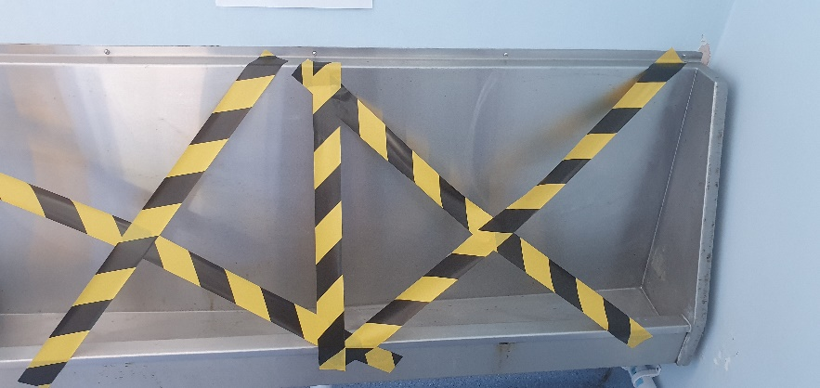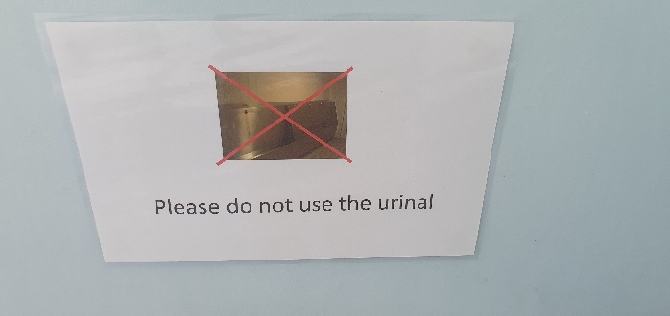

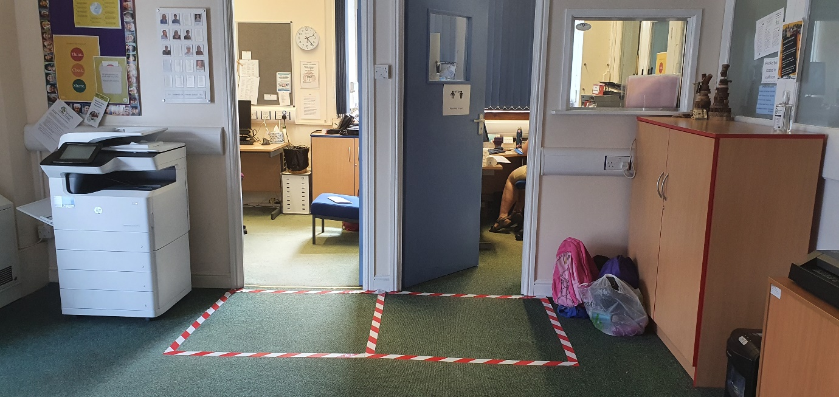

Wait outside of the red box, if you need to see the office staff.

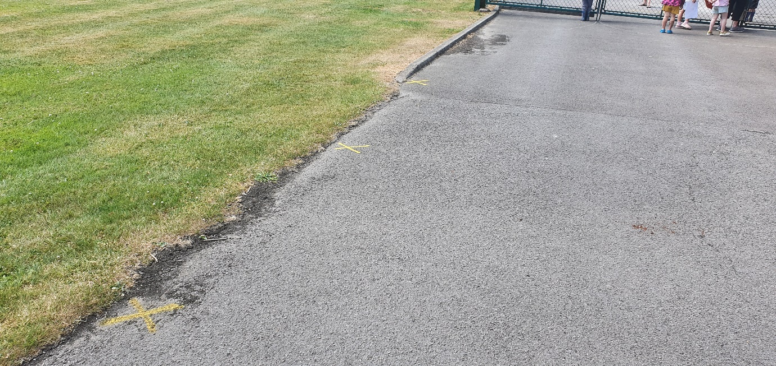

KS2, when you go home, stand on a yellow X until your teacher sends you to your parent.