[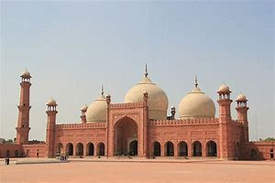](https://www.bing.com/images/search?view=detailV2&ccid=3QMXSSTc&id=30A8C2E5E249FB31517AE5159E7CD568C38682B0&thid=OIP.3QMXSSTcG3Q0DVsNxYvlRQHaE8&mediaurl=https%3a%2f%2fupload.wikimedia.org%2fwikipedia%2fcommons%2fthumb%2fc%2fc8%2fBadshahi_Mosque_front_picture.jpg%2f1200px-Badshahi_Mosque_front_picture.jpg&exph=800&expw=1200&q=MOSQUE&simid=608052349178347822&selectedIndex=9)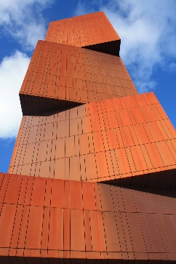[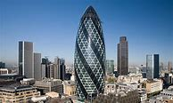](https://www.bing.com/images/search?view=detailV2&ccid=uEYyfr8M&id=722EBDFE8FB8F965FAF20F0F797E8A89F9B96E0A&thid=OIP.uEYyfr8M7M7bCBHTVTTCHgHaEc&mediaurl=http%3a%2f%2flondontopia.net%2fwp-content%2fuploads%2f2015%2f06%2fThe-Gherkin_safra-group.jpg&exph=1536&expw=2560&q=GHERKIN&simid=608035534413892514&selectedIndex=0)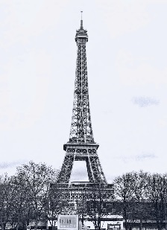[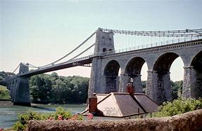](https://www.bing.com/images/search?view=detailV2&ccid=0aROPn%2b3&id=7961E5787463FB5A120AEB350B0653A1D1454107&thid=OIP.0aROPn-3slQYnyynjD6JuwHaE1&mediaurl=http%3a%2f%2fwww.ce.jhu.edu%2fperspectives%2fprotected%2fids%2fBuildings%2fMenai+Bridge%2f1.jpg&exph=2132&expw=3262&q=buildings+and+structures&simid=608053921135002177&selectedIndex=37)

As geographers, we would like to explore:

* Countries and continents around the world.
* What are the major cities.
* Comparing bridges in the UK, Europe and USA.
* How to use a map.

As historians, we would like to explore:

* When our school was built.
* What the school would have looked like in the Victorian times.
* What famous or significant buildings there are locally.
* Famous builders like Brunel and what they built.
* Bridges and how they have developed.

As artists and musicians, we would like to explore:

* The work of Andy Goldsworthy.
* Looking at Art in nature.
* The structure of a piece of music and composing our own.

As users of technology, we would like to explore:

* How structures are formed.
* How things work and how they are put together.

As scientists, we would like to explore:

* Forces and magnets.
* Sound.
* Properties of material.
* Human habitats and our effect on the environment

Maths

As well as our maths curriculum, we will also look at the height of famous buildings, the weight of different building materials

**Builders and Structures**

As spiritual people, we will explore:

Places of worship

How people pray

Pilgrimages and significant religious buildings.

Personally and socially we will be discussing our values, our uniqueness and the pressures the internet has on our friendship groups.

As healthy people, we will be thinking about the safety of ourselves and others. We will learn how to identify a problem and take responsibility for our actions.

As members of our community we will find out about when our school was built and what life was like in Tortworth at that time. We will also be studying some famous local buildings

As linguists we will be extending our knowledge of French and look at the Eiffel Tower

We will develop our *Diamond Power* by learning how to identify a problem and take responsibility for our actions.

Reading and Writing

As well as following our English curriculum for Phonics, Grammar, Spelling and Handwriting, we will also be using a variety of texts for Guided Reading and as an inspiration for our Writing, including:

Year 5/6 will be looking at the book Cogheart by Peter Bunzl and learning how to write non chronological reports and newspaper articles.

Year 3/4 will be looking at non chronological reports and biographies.