Welcome to Peregrine class (year 5 and 6) ( I know a new name!!!!!) We hope you have had a fantastic summer and are refreshed and ready for the work ahead. We are very excited for this new term, which we hope will be filled with fantastic learning experiences for your children. As you know Mrs Bonner and Mrs Hughes will be teaching your child in the mornings. We will be teaching English, Maths, Science; including Punctuation, Grammar and Spelling. So as you can see, the mornings will be very busy.
In the afternoon the children will be focusing on our overriding theme “To Infinity and Beyond” which encompasses all things Space related, ranging from Hubble telescopes to alien beings! It’s going to be a busy term!!!
As a Year5/6 class we are going to be asking the children to take on many different roles and responsibilities around the school to aid their independence, organisational skills and sense of responsibility. We know that you will help with this at home, by encouraging your children to prepare for the day ahead on their own. With this in mind, the front of the Reading Home Book you will find a timetable of the week.
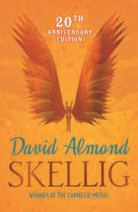
Literacy
In Literacy we are going to be reading a book called Skellig by David Almond. This is a magical book with strong characters, an exciting story line and magnificent writing. However, the book does contain some mild language and I can assure you that, when we reach this part in the story, this will be handled in a careful and sensitive way. If you have any concerns about this please do not hesitate to talk to us.
Numeracy
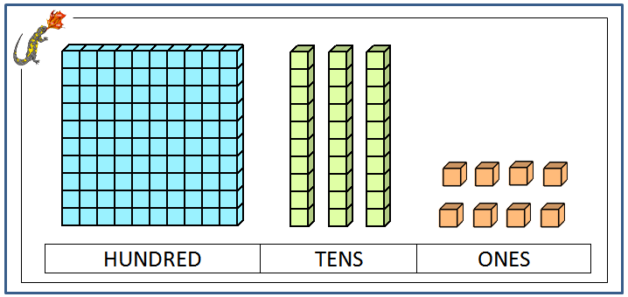
Numeracy will begin by looking at Roman Numerals and then focusing on Place Value where we will learn to read and write numbers in words and numerals, estimating, ordering and many practical applications.
We will also be putting a strong emphasis on learning our times tables and lots of mental calculations.
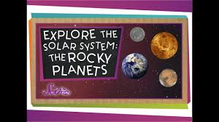
Science
In Science, we will be learning about the Sun, Moon and Earth. Children will learn how the Earth rotates and the orbit of the moon along with many other space facts and theories.
Here are a few pointers you may need for class organisation:
Water: We love children to have water bottles as this can help them learn. Please only fill them with water, for health reasons and sticky book reasons!
Slippers: As the weather gets colder and the ground muddier we are happy for the children to bring in sensible (not huge cumbersome) slippers to wear in class. These can be left in school and used during lesson time.
Hot chocolate and toast: I would like to trial a hot chocolate and toast break time just for Peregrine class. To begin with it will just be once a week, Wednesday, but if it proves successful we will do it more break times. Toast will be 10p a slice and Hot chocolate 20p a cup (please bring in your own mug)
Clothes: Please can the children have PE kits (white t-shirt, trainers and shorts/tracksuit bottoms) in school on a Tuesday. Forest school clothes and wellies are needed in school at all times, as you never know where our learning could take us. Forest school is timetabled for Tuesday this term.
Read: You will have seen a red Reading Home Book. This book is for you and your child to record any reading they do at home. Allow them to read at home as often as you can it really will help their learning. Let them read to you, to younger siblings, to themselves and record it in this book. This book will be looked at every week so you can also make comments in there for us to read.
Homework: Homework will be a topic based activity per term. A letter will follow shortly about this. In addition to this, weekly spellings will be sent home for children to learn, practice and start to use. We will not be testing these weekly as we hope to start seeing the words in the children’s work. There will be termly tests and these words will be actively used in class.

